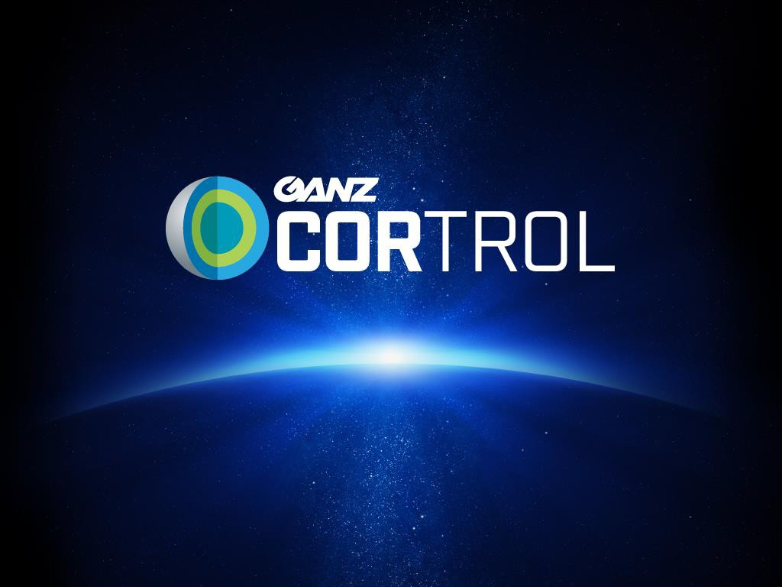

SPECIFICATIONS AND FEATURES

Rev. October 2020

A&E Specs
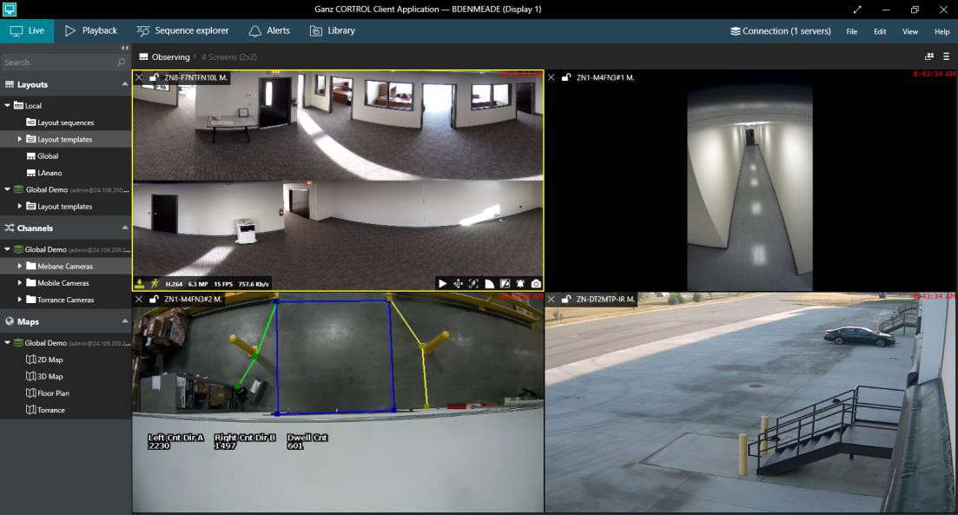
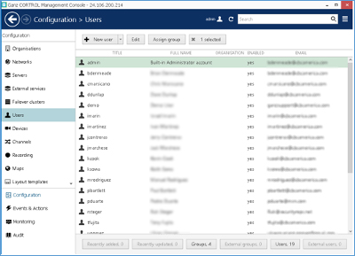

Ganz CORTROL is a highly stable software, easy to use on any network and very easy to deploy with the advanced Auto Detection feature for IP cameras. Ganz CORTROL also provides extreme flexibility as it can manage unlimited servers, sites, and cameras remotely, quickly, and efficiently. Ganz CORTROL is an open architecture Video Management Software (VMS) for Windows. Ganz CORTROL accepts MJPG, MPEG-4 and H.264, as well as Full HD and megapixel video streams from Network (IP) cameras, encoders, and capture boards. This, along with Ganz CORTROL client-server architecture, allows you to build hybrid scalable solutions from a single NVR/DVR to multiple servers handling thousands of cameras.

Ganz CORTROL accepts video streams from Network (IP) cameras from 140+ manufacturers including all major manufacturers such as Axis, Arecont Vision, Pixord, SONY, JVC, Panasonic, IQinVision, Toshiba, Zavio, Acti, Vivotek and UDP (more than 4000+ models supported) Ganz CORTROL also works with several DVR cards, like H.264, SDI "HDCCTV" (up to 960fps and up to 64 channels at D1 resolution) boards from UDP and other manufacturers. Moreover, Ganz CORTROL is a hybrid system, since a DVR card with analog cameras, IP cameras, webcams and IP megapixel cameras, could be combined on a single server.

Optimized and designed for Microsoft Windows Server 2008/2012 / Windows 7/8.1/Windows 10.

Surveillance from anywhere: multiple client options are supported, including Ganz Monitor, Web client, Ganz CORTROL Mobile client app for IOS, and Android. Web client for Ganz CORTROL Streaming Server supports Chrome, Firefox, Safari, iOS, Android, etc.

Full-featured Client application – All functions, without exceptions may be controlled both locally and remotely (only one user interface). Anyone operating the client application can connect to the server, access live and recorded video, change settings, etc. in accordance with granted user rights. It enables quick navigation between cameras from any server.

Full range of editions: for all needs and budgets from home users to large enterprises.

32- and 64-bit support

Multi-Language Support: English, Italian localization, with many more to be added.

Enterprise Scalability and Monitoring: All functions such as: Screen Mapping, Layout Sequencing, Alert Notifications, PTZ Control, Camera Configurations and more without exception may be accessed and administered both locally and remotely allowing management and administration for an unlimited number of servers around the world. Flexible Event & Action configurator enables you to manage events and notifications such as emails, text messages and more tasks for multiple servers from a single interface.

Ganz CORTROL API/SDK Included: Developed for future. It allows to integrate third party applications. Custom programming and exclusive features also available. Ganz CORTROL offers customizable integration with other software systems in form of software development kit (SDK), Ganz CORTROL ClientKit.

Ganz CORTROL simplified HTTP API allows implementation of many different features for third party applications and systems.

Server & Console

Server core with Remote & Local System Configuration
  - Configuration import/export via XML file
  - Server runs as Windows Service

Central Server Management via Console Application
  - Ganz CORTROL Global server provides ability to combine many servers (theoretically unlimited) under centralized management
  - Configurable TCP port (default is 60554)
  - Unlimited number of recording servers and failover nodes can be involved without any imposed limitations

Video Support
  - Supported codecs: H.264, MPEG4, MJPEG, JPEG, MxPEG
  - RTSP, HTTP, and native video transport supported
  - Configurable compression, resolutions, FPS, bitrate (exact available settings depend on camera)

Support for IP and Analog Devices
  - Support of wide range of IP cameras and video encoders: all IP cameras on the LAN may be configured via Auto Search Wizard. Using the Wizard, a user can find all Network IP cameras available within the network. The user can configure them and connect them in no time and with little effort.
  - Each camera is individually configurable
  - Support for video, audio, hardware-side motion detectors and digital I/O
  - For IP Camera compatibility, follow link: http://ganzsecurity.com/product/1439/CORTROL
  - ONVIF Profile S support
  - Generic drivers (RTSP, MJPEG, PSIA, ONVIF)
  - Support for Direct Show compatible devices: the list of these devices includes everything from very basic USB cameras to camcorders to advanced multichannel video capture boards. These devices can be used alone or together with supported hardware and/or IP cameras, including GigE cameras installed via DirectShow driver.
  - Capture boards
  - External I/O devices via TCP/IP
  - Video streaming from Android and iOS phones and tablets
  - Camera search (automatic discovery)
  - Single and multiple (bulk) device configuration

Archive Recording
  - Channel replication (backup)
  - Flexible recording setup
  - Substreams
  - Audio
  - Schedules
  - Reduced frame rate
  - Dedicated storage
  - Recording by motion and alarms of different kinds (DI, VCA events, custom events)
  - Bookmarks

Edge Recording Support
  - For ONVIF Profile G conformant devices

Recording Options
  - Recording of video, audio, DI event streams
  - Configurations and profiles
  - Pre- and post-recording for event-based recording plans
  - Automatic triggering of unlimited number of recording profiles for a wide variety of events
  - Manual controlling of recording profiles via Ganz CORTROL Monitor application, e.g., emergency recording start/stop
  - Duration and storage quotas
  - Configurable storage cleanup hours
  - Schedules
  - Individual stream quotas for storage and duration
  - Fully independent recording, storage, and quota setup for dual streaming (main and secondary stream)

Watchdog
  - Protects the software from certain types of failures by automatically attempting to restart the service and the server machine, if required
  - Scheduled restarts (default maintenance restart period is one week) with configurable time limitations
  - Operates based on the software and system overall health monitoring
  - Default trigger values selected based on extensive tests run on systems of different configuration and stability levels
  - Configured for each server independently
  - Logging of watchdog activity

Motion Detector
  - Camera-side motion detection support for most devices: analysis of raw (non-compressed) video stream on the device side decreases resource usage on the server side and provides best detection results
  - High performance software motion detector mode: analysis of key frames only, lower CPU and memory usage, limited accuracy
  - High accuracy software motion detector mode: analysis of the whole video stream, maximum accuracy for motion detection on a compressed video stream. Recommended for use cases where motion shorter than 1 second must be detected.

Camera-side VCA Event Support
  - List of vendors (including ONVIF Profile S devices)
  - DATA MINING for post event analysis and data management
  - Sensitive tracking with a low false alarm rate
  - VCA adapts automatically to varying lighting and weather conditions
  - Simple detection zone setup
  - Fire and Smoke – WARNING - The smoke and fire video analytics do not comply with any detection standards and should not be used as a safety device. VCA should only be installed in addition to certified safety devices and used only to supply additional information.
  - VCA enabled encoder/camera can be used as a stand-alone intruder sensor or digital output contact can be set to react to specific triggers
  - Analytics stabilization allows software to work effectively on swaying cameras
  - Rapid 'learning time' of just a few seconds. Can be used with PTZ cameras - detection is suppressed during camera movement

  - Unique features - PTZ auto tracking, fog and smoke reduction, image stabilization and camera tamper
  - VCA has NO single point of failure, because the Analytic s is integrated on the Edge HW, Video server or into the Camera
  - VCA is very easy and simple to configure even for installers with limited experience
  - VCA fits many market segments without modifications

Software VCA Support (requires additional license)
  - Video Analytics with DATA MINING Filters
  - No extra hardware required
  - Counting lines
  - Camera Tamper Detection
  - Camera Shake Cancellation
  - Surveillance tracker
  - Presence filter
  - Appear and Disappear Filters
  - Abandoned Object Detection
  - Removed Object Detection
  - Class and speed filters + calibration
  - Direction & dwell filters
  - Tail-gating filter
  - On-screen counters
  - Object Meta data
  - Counting (people, cars, object counting): highly accurate information on the number of people who enter their premises to use their facilities. It can apply to different applications, such as airports, bus and train stations, bars and clubs, car parks, retail stores and shopping malls, museums and tourist attractions, sports, and leisure facilities, and many more.

Events & Actions (E&A)
  - Send emails notifications: text macros are supported for automatic insertion of such data as timestamp, event source etc.
  - Send custom notifications via Run third party program feature, for example, using telnet or generic socket connections
  - Events: Disk Excluding, Video Lost, Video Restored, Motion Events, VCA Events, Digital Input, user's events, scheduled event (clock event)
  - Actions: PTZ preset, Digital Output, Write to Application/Event log, Activate Layout, Popup Live Channel/Layout, Email notification, Run program, Activate Recording profile for dual streaming,
Highlight Camera on the Map
  - Multiple SMTP server configuration: use many different email servers
  - Rule schedules: configured rules can be triggered on weekends or working days only, or follow a fully custom time schedule
  - Global events: share events between servers and make events from one server trigger actions on another one
  - Rule combining (conditions): use two events (event conditioning) to trigger a single action
  - Event postponing and aggregation (timers): action execution may be postponed for the required amount of time
  - Single event can trigger an unlimited number of actions

Audio Support
  - Receive audio from device: supported compressions are G.711 (PCM a-law and u-law) and raw audio.
  - Transmit to device (two-way audio)
  - External audio source support (microphone connected to the server directly or using additional hardware)

Organizations
  - Enterprise feature for hosted solution providers or projects that require splitting of resources on a logical basis
  - Sub-administrator role with the ability to create/manage new user accounts inside the organization and manage resource permissions
  - Resource management: channels, sub-admins and regular users can be assigned to organizations

Failover Clustering
  - Failover setup for recording servers
  - Unlimited number of failover clusters and failover nodes (servers) available for Ganz CORTROL Global without any extra fee
  - 1-to-many, many-to-1 configurations supported
  - Automatic failover server starts in case of a failure with an option to define time for failover event triggering
  - Failover server can be forcibly (manually) started to take over operation of a recording server, allowing server hardware maintenance procedures without any system downtime
  - Real-time node status monitoring

Multicast Support
  - Video via multicast from cameras to server(s)

Networks
  - Enterprise feature for sites with multiple different networks: provides centralized connection via central server address
  - TCP/IP routing configuration for Ganz CORTROL Global installation
  - Makes system infrastructure transparent for the user

Groups
  - For easy resource management
  - Grouping available for: servers, users, devices, channels, e-maps, shared layouts, layout templates, video walls, user buttons
  - Visual groups for resource arrangement in Ganz CORTROL Monitor application

Users
  - User details: login, password, email, organization attachment, PTZ priority
  - Resource permissions for organizations, servers, networks, devices, channels, e-maps, user buttons, layout groups, video walls
  - Membership in groups, nested and/or overlapping groups can be configured
  - Virtually unlimited number of users

AD & LDAP
  - Export of users from Active Directory
  - Support for Active Directory groups
  - Automatic synchronization for the deleted and newly created users

Health Monitoring
  - Real-time monitoring for servers, devices, channels, user sessions, video walls and external services (LPR, FR)
  - Connectivity, failover, video stream status

Audit Log
  - Logging of important events, such as: user log in/log out, administer server, access live/recorded video, server connected/disconnected, configuration added
  - Event reports for servers and users
  - Event filtering by period, by event or by server/user
  - Audit export to a CSV file

E-Maps
  - Group and organization attachment
  - All popular image types supported: JPG/JPEG, PNG, TIF, BMP, static GIF
  - Images of size up to 8.25 megapixels
  - Markings for devices, user buttons and links to other maps for easy navigation
  - Variety of icons and colors to choose from for each object placed on the map
  - Ability to zoom into map, and pan around map

Layout Templates
  - Custom layout templates for the Ganz CORTROL Monitor application
  - Up to 20 rows/columns, up to 100 viewports per layout in total

Layouts
  - Groups for sharing layouts between multiple Ganz CORTROL Monitor applications throughout the whole system

User buttons
  - Manual action controls for Ganz CORTROL Monitor: user buttons are used to manually trigger events, which can be linked to any available action including DO control, activation of recording profiles, notifications
  - Schedules, timers and conditions can be applied in the Event & Action Configurator for user button related rules just as for any other regular Event & Action scenarios.

External services
  - LPR - Ganz License Plate Recognition software (separate application)
  - FR - Ganz Face Recognition module (separate service)
  - HTTP API interface for third party integration and events' exchange - e.g., access control systems, POS systems, building management systems etc.

Client
- Free distribution - license free application
- Multiple servers can be connected to a single Ganz CORTROL Monitor
- Multiple displays for live view and main multi-purpose window
- Configurable viewport overlay controls in live mode
- Configurable viewport overlay controls in playback mode
- Snapshot and video export

Live View
  - Live video streaming to one or multiple client applications without delays
  - Dual streaming support with automatic switching mode for optimal resource and bandwidth usage
  - Two-way audio support
  - Global and individual stream aspect ratio

Instant Playback
  - Playback of the newest footage simultaneously with the live view
  - Supported for one or multiple viewports

Archive Playback
  - Multichannel playback
  - Channel layout is retained from live view mode
  - Dual timeline presenting the currently selected channel and the summary for all channels present on the layout
  - Up to 32x speed playback in both directions
  - Video, audio, and motion marking on the timeline
  - Controls for browsing timeline in both directions
  - Snapshot and video clip export
  - Bookmarks

Sequence Explorer
  - Footage sequencing: splitting the video from specified time range into specified number of pieces
  - Quick visual investigation of the footage by the means of repeated sequencing, down to 2 minutes each portion of footage
  - Smart search by motion region

Joysticks and DCZ Support
  - Default set of commands for keyboards and DCZ keyboards
  - Custom command mapping for any type of keyboard/joystick
  - Generic DirectShow compatible controller devices are supported
  - Multiple application windows can be controlled with joysticks and DCZ keyboards

Operation Modes
  - Exclusive: application does not allow accessing other applications until a pre-defined password is provided
  - Always on top: application window stays on top of other windows
  - Locked: application controls are not available until a pre-defined password is provided
  - Combined settings for operation modes
  - Startup operation mode setting
  - Screen saver overriding

Screen Layouts
  - Built-in layout templates for each Ganz Monitor application
  - Custom layouts that can be saved locally on the client workstation or shared via central server
  - Shared layouts: layouts are shared between all Ganz Monitor applications via central server
  - Individual viewport settings in the live view are saved with the layout
  - PTZ presets and DPTZ positions for each individual camera are saved with the layout
  - Layout sequences: automatically loaded series of layouts with the possibility of manual control and controllable time per layout

PTZ

- Generic PTZ: pan, tilt and zoom controls available for PTZ-capable devices
- PTZ controls for Ganz Monitor as well as for Ganz CORTROL Mobile and Web clients
- DCZ keyboard and generic joystick support for PTZ control and related actions, such as calling presets
- HUD: Heads Up Display control overlay for Ganz Monitor application
- PTZ controls can be hidden via application settings for Ganz Monitor
- Presets
- Preset positions for each camera are saved with the layout
- PTZ Tours: custom sets of presets for the PTZ camera to follow

Digital PTZ
    - Supported for any video stream
    - For live view and playback modes
    - DPTZ settings saved and loaded with the layout
    - Single video stream can be displayed multiple times with different regions of interest

Fisheye Dewarping
    - Generic dewarp for any fisheye image
    - Configurable via Ganz CORTROL Console application
    - Region mode, 180-degree and 360-degree panorama
    - ImmerVision Enables® Panomorph lens support

E-Maps
    - Can be displayed in any viewport just like any regular channel
    - Map contents is interactive: it is possible to click the markers on the maps to display related contents, e.g. other maps and channels, and to trigger custom actions assigned to user buttons placed on the map

Alerts for server connection errors and user actions

  - Library
    - Pre-configurable library directory
    - Pre-configurable default settings for snapshot and video export

  - External Services: representation of data from LPR, FR and third-party integrations

Video Wall
  - Convenient management of monitoring workstations in big installations with large number of displays
  - Unlimited number of video walls - no extra fee
  - Up to 100 physical displays per each video wall - up to 20 rows/columns and up to 100 viewports per layout
  - Send individual channels to the video wall manually via user interaction from the Ganz CORTROL Monitor application or automatically via Event & Action scenarios, including half-automated solution with user buttons

Watermark Validation
    - All data is signed while received and recorded
    - AVI and JPEG codecs
    - Portable tool

SDK
  - Client Kit API for customizable integrations with third party software systems, available functionality:
    - Access live video from one or multiple local or remote servers
    - Access archived video from servers
    - Configure camera and recording settings
    - Receive motion detection notifications
    - Create and delete media devices
    - Adjust software motion detector properties
    - Receive motion region information for media device
    - Export archive video (with optional subtitles if exported with recompression)
    - Pan/tilt/zoom/focus (PTZF) control motorized and otherwise PTZF-enabled cameras

  - Client Kit API requires two ActiveX components to be installed: CDVRClientKit and CScreen
  - Client Kit API Is based on Microsoft Component Object Model (COM) technology and can be used with various development environments
    - Microsoft Visual Studio .NET (VB.NET, C#, C++) and earlier versions (VB), Borland/Inprise Delphi

  - Simplified HTTP/CGI API - Already included in the software installation

Mobile Applications
  - Android & iOS ready
  - Live video streaming
  - Video playback - access to recorded video streams
  - Two-way audio
  - PTZ control for live view: pan, tilt and zoom for PTZ-capable devices
  - Chromecast support
  - Live video and audio streaming from mobile app to the server
  - No stream re-compression on the server side - no extra CPU usage
  - Main and sub stream switching
  - 1x1, 2x1, 2x2 and 3x2 stream layouts
  - Snapshot saving
  - Multiple server setup
  - Built-in and Active Directory user login
  - Connect over Wi-Fi, 3G and 4G

OS X Client
  - Live video streaming
  - Video playback - access to recorded video streams
  - Two-way audio
  - PTZ control for live view: pan, tilt and zoom for PTZ-capable devices
  - Chromecast support
  - No stream re-compression on the server side - no extra CPU usage
  - Main and sub stream switching
  - 1x1, 2x1, 2x2 and 3x2 stream layouts
  - Snapshot saving
  - Multiple server setup
  - Built-in and Active Directory user login
  - Connect over Wi-Fi, 3G and 4G

Web Client
  - Local and remote access via dedicated configurable HTTP port
  - Live video streaming to browser Client application
  - Access to recorded video streams
  - Pan, tilt and zoom control for PTZ-capable devices
  - 1x1, 1x2, 2x1, and 2x2 stream layouts
  - Main and sub stream switching
  - No stream re-compression on the server side - no extra CPU usage
  - Built-in and Active Directory user login

LPR (License Plate Reader) - Modula Add-on
  - Designed to detect, recognize, and register vehicle license plates with a high level of reading reliability
  - Intuitive installation process
  - Designed to work with Ganz CORTROL with both live and recorded streams
  - Works with any camera Ganz CORTROL supports
  - Live result presentation in Ganz CORTROL
  - Result browsing in Ganz CORTROL
  - Can be used for vehicle access, traffic control and enforcement applications
  - High performance recognition with low error rate
  - Recognizes license plates from multiple countries
  - Supported countries:
    - AL DZ AR AU AT AZ BH BY BE BO BA BR BN BG CA CL CO CG CD CR HR CZ CU DK EG EE EC FN FR DE GE GH GR GT GG HK HR HU IN ID IR IE IM IL IT JE JO KZ KP KR KW LV LB LT LU MK MY MX MD MC NZ NL NG NO PK PY PE PH PL PT QA RO RU SA RS SG SK SL ZA ES SE CH TW TZ TN TR UA GB US UY VE VN

  - Recognition area adjustment for system load optimization
  - Lighting conditions adaptive algorithm
  - Support for local and remote unlimited “White” and “Black” lists
  - Result re-filtering
  - Interface to external applications and devices
  - Storing recognized license plates and snapshots on local or central database
  - No imposed limitation on the number of cameras

Face Recognition - Modula Add-on
  - Designed to work with Ganz CORTROL Premier and Ganz CORTROL Global
  - Suited for human resource control applications as well as for security and enforcement applications
  - Simultaneous multiple face recognitions
  - 1-to-1 and 1-to-N face matching modes
  - Simple interface
  - Simultaneous processing of multiple video streams
  - Connection to one or more Ganz CORTROL servers
  - Local or central database

